Software Requirement Specifications
For Integrated Medical Booking System

Prepared by:
Team Members | Department | Employee ID
Toh Si Pei | Project Lead | 2401835
Alyssa Yu | Backend Developer | 2402077
Galvin Yap Min Jn | Research & Development  / Account Manager | 2401574
Mohammed Shaqeel Bin Mohammed Sidek | Cybersecurity & Privacy Expert | 2401223
Randy Kwok Zhen Zhou | Business Analyst | 2401425
Reuben Loo Jie Long | Quality Assurance Officer | 2203657

Date: 24 February 2026
Document ID: PT-SRS01
Version: 1.0
Confidentiality Notice:
This document contains proprietary information belonging to Pingu Tech.
Unauthorized distribution is strictly prohibited.

Table Of Contents
Cover Letter 4
1. Introduction 1
1.1. Purpose 1
1.2. Document conventions 1
1.3. Intended Audience 2
1.4. References 2
2. Overall Description 4
2.1. Product Perspective 4
2.2. Product Functions 4
2.3. User Classes & Characteristics 4
2.4. Operative Environment 5
2.5. User Environment 5
2.6. Design/Implementation Constraints 5
2.7. Assumptions & Dependencies 5
3. External Interface Requirements 6
3.1. User Interfaces 6
3.2. Hardware Interfaces 6
3.3. Software Interfaces 6
3.4. Communication Protocols & Interfaces 6
4. System Features 7
4.1. User Registration & Authentication 7
4.2. Role Based Access Control 8
4.3. Appointment Booking & Management 8
4.4. Notification Management 9
4.5. Doctor Availability Management 10
4.6. Waiting List Management 11
4.7. Referral Processing 12
5. Other Non-Functional Requirements 13
5.1. Performance Requirements 13
5.2. Safety Requirements 13
5.3. Security Requirements 13
5.4. Software Quality Attributes 14
5.5. Business Rules 14
5.6. Project Documentation 14
5.7. User Documentation 14
5.8. Change Mitigation 15
6. Sign-Off 15
Appendix A - AI Declaration
Appendix B - Plagiarism Declaration
Appendix C - Template Source
Appendix D - Glossary
Appendix E - Diagrams
Appendix F - Repository
Appendix G - iRTM

Cover Letter

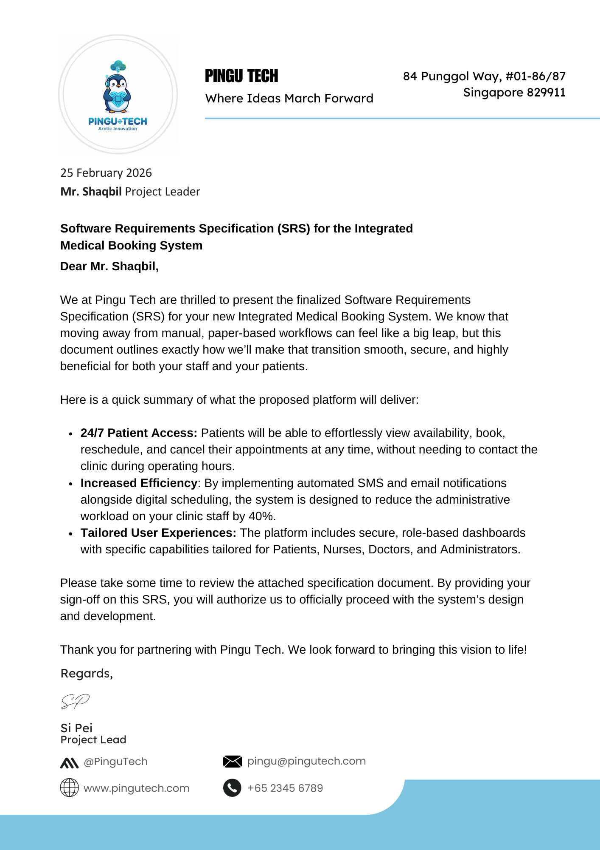

Introduction

Purpose
The purpose of this document is to define the software requirements for the Medical Inc. Integrated Booking System, developed by Pingu Tech. This Software Requirements Specification (SRS) provides a comprehensive description of the system's intended behavior, features, and constraints, serving as the primary baseline for the development, testing, and delivery phases of the project.
The primary objective of the proposed software is to transition Medical Inc. from a manual, paper-based scheduling workflow to a secure, cloud-based digital platform. By unifying operations across Medical Inc.’s three clinic locations in Singapore, the system aims to solve existing operational bottlenecks and achieve critical business goals.

Document conventions
- Requirement Identification: Each requirement is assigned a unique identifier to support traceability and testing.
  - E.g. FR-AUTH-01 (Functional Requirement - Authentication - 01)
- Model Identification: All diagrams are referenced using Figure X.Y format.
  - E.g. Figure 1.2
- Imperative Language:
  - The word "shall" is used to denote mandatory, essential requirements that the system must fulfill.
  - The word "should" denotes a desirable but non-mandatory requirement.
  - The word "may" denotes an optional requirement.
- Priority:
  - Essential: Mandatory for system acceptance.
  - Desirable: High-value features that are not critical for launch.
  - Tolerable: Optional features that can be deferred.
- Template Source and Adaptation:
  - Source: See [Appendix C]
  - To fulfill the specific engineering requirement of the Medical Inc. Integrated Medical Booking System project, the Ping Tech Project team heavily adapted the baseline template by adding the following custom sections
    - Codification Schema: Added a strict requirement identification system.
    - Integrated Requirements Traceability Matrix (iRTM): Added to map every functional and non-functional requirement back to its originating source and forward to its verification method.
    - Change Mitigation protocol: To Define a strict, controlled process for managing modifications to the approved requirements.

Intended Audience
This specification is a multi-disciplinary document designed to serve various stakeholders throughout the project lifecycle.
The following table outlines the intended audience and how each role should utilize this document to achieve their project objectives
Organization | Role | Purpose/Document Usage
Vendor  (Pingu Tech) | Project Manager | For Project planning, tracking, change control and utilizing the specification as the official baseline to debrief the development team.
 | Account Manager | For managing scope boundaries, and maintaining a transparent client relationship.
 | Development Team | For designing system architecture, deriving internal components, and implementing core features.
 | Quality Assurance | For formulating comprehensive test cases, building validation plans, and auditing the software against defined requirements.
 | Support Team | For understanding the system’s intended behavior and troubleshooting operational parameters post-deployment.
Client  (Medical Inc.) | Stakeholders & Users | For confirming that business requirements are accurately captured and evaluating how usable the described features will be in daily workflow.
 | Project Manager | For validating project scope, verifying requested features are documented and checking the specification for any additional costs.
 | Department Manager | For evaluating the described features to determine how inclusive, timely, and useful the new software’s scheduling workflows and automated functions will be for daily operations.

References

Document / Standard title | Version / Date | Source / Author | Purpose in Project
Medical Inc. Project Specification | 1.0 | Medical Inc.  (Client) | Defines core business objectives and scope constraints.
 |  |  | Linked Reqrs: FR-HWI-01, FR-SI-DB-01, FR-RBAC-02, FR-BOOK-01, NFR-SEC-01, NFR-SEC-02.
Pingu Tech Analyzing Report (AR-1223) | 1.0 | Pingu Tech  (Vendor) | Documented elicitation and finalized scope agreement.
 |  |  | Linked Reqrs: FR-UI-01, FR-BOOK-02 through FR-BOOK-09, NFR-PERF-01 through NFR-PERF-03, NFR-SAFE-01 through NFR-SAFE-04.
Personal Data Protection Act (PDPA)  &  Ministry of Health (MOH) Guidelines | 2012  (Updated)  AG/LEGIS/SL/227A/2020/3 Vol. 1 | Singapore Government | Legally binding constraints for healthcare data retention, audit logs, and encryption.
 |  |  | Linked Reqrs: NFR-SEC-01, NFR-SEC-03, NFR-SEC-04, FR-AUTH-04, FR-REF-04.
GovTech SingPass OIDC API Documentation | Current | GovTech Singapore | Technical baseline for identity verification integration.
 |  |  | Linked Reqrs: FR-SI-SP-01, FR-AUTH-06.

Overall Description

Product Perspective
The Integrated Booking System is intended to provide a modern, web-based alternative to the current manual, paper-based appointment scheduling processes used across Medical Inc.'s clinics. The manual approach has proven to be inefficient, resulting in recurring double-booking incidents and high administrative overhead that diverts staff attention from patient care. This web-based platform will centralize appointment scheduling, improve patient accessibility via 24/7 self-service, saving time and reducing the administrative workload for clinic staff. Also, the system centralizes data across 3 clinic locations, ensuring that patient records and schedules are synchronized without the involvement of siloed, location-specific paper records.

Product Functions
The usage of the new integrated booking system will:
- Eliminate manual scheduling processes, and reduce the administrative workload on clinic staff by 40%.
- Allow patients to view available slots, book, reschedule, and cancel appointments 24/7 without needing to contact the clinic during operating hours.
- Provide automated SMS and email notifications for immediate booking confirmations, 24-hour reminders, and cancellation alerts.
- Ensure 100% real-time data consistency across all 3 clinic locations to eliminate inconsistencies or outdated data.
- Provide secure, role-based access to specific dashboards and capabilities for Patients, Nurses, Doctors, and Administrators.

User Classes & Characteristics
The users of the application can be classified into four types: Administrators, Doctors, Nurses, and Patients. There is a strict distinction between the user types, enforced by role-based access control.
- Patients: Access the system to book appointments, view history, and manage profiles. They require simple, accessible interfaces.
- Nurses: Manage appointment schedules, patient payments, and basic medical records. They possess varying levels of technical proficiency.
- Doctors: Use the system to manage their availability schedules, view patient lists, access in-depth medical records, and authorize hospital referrals.
- Administrators: Oversee clinic management, generate reports, and manage user roles and configurations

Operative Environment
The application is a responsive web application, so it will be able to work on most devices equipped with a modern browser without requiring native OS-specific installation.
- Devices: Mobile Phones, Computers, Laptops, Tablets.
- Operating System: Windows 10/11 and macOS.
- Browsers: Mozilla Firefox, Google Chrome, Safari, Microsoft Edge.
- Server/Hosting: Secure, scalable cloud infrastructure (e.g., AWS, Azure, Google Cloud) with data residency in Singapore.

User Environment
- Patients will access the system remotely via their personal mobile or desktop devices.
- Clinic staff (Administrators, Doctors, Nurses) will access the system primarily on-site using clinic-provided computers.

Design/Implementation Constraints
- CO-1: The time allotted for this project deployment across all 3 clinics is at most 6 months.
- CO-2: The frontend of the application will be developed using modern frameworks such as React, Angular, or Vue.js.
- CO-3: Python (Django) will be used for backend development, while MySQL will be used as the relational database system.
- CO-4: The system must strictly adhere to Singapore's Personal Data Protection Act (PDPA) and Ministry of Health (MOH) guidelines regarding data retention and audit logs.
- CO-5: Sensitive payment data (PAN/CVV) must absolutely not be stored within the application database.
- CO-6: The application will be available in English, Chinese, Malay and Tamil. Users that do not know them might face difficulties using the website.

Assumptions & Dependencies
- AS-1: It is assumed that existing manual patient records can be migrated to the new database with minimal data transformation.
- AS-2: Clinic staff will have adequate internet connectivity and devices to reliably access the web-based system.
- AS-3: There will be no major regulatory changes to PDPA or MOH guidelines during the 6-month development lifecycle that would force unexpected core logic rewrites.
- DE-1: The application will depend on integration with a certified payment gateway to support Visa, Mastercard, Google Pay, Apple Pay, and PayNow transactions.
- DE-2: The system relies on external third-party APIs for automated SMS and email notifications.
- DE-3: The optional patient registration and identity verification features depend on the availability of the GovTech SingPass API.

External Interface Requirements

User Interfaces
- FR-UI-01 (Cross-Browser Compatibility): The system shall be fully functional and visually consistent across the latest stable versions of Google Chrome, Mozilla Firefox, and Apple Safari.
- FR-UI-02 (Mobile Responsiveness): The interface shall employ a "Mobile First" responsive design, supporting screen widths ranging from 375px (mobile) to 1920px (desktop).
- FR-UI-03 (Accessibility - WCAG): All UI components shall adhere to WCAG 2.1 Level AA standards to support elderly users and those with visual impairments.
- FR-UI-04 (Efficiency of Use): System navigation shall ensure that core features (Booking, Profile Management, History) are reachable within a maximum of three (3) clicks from the main dashboard.

Hardware Interfaces
- FR-HWI-01 (Cloud Hosting): The application shall be deployed on secure, scalable cloud infrastructure (e.g., AWS or Azure) with data residency in Singapore.
- FR-HWI-02 (Client-Side Requirements): The system shall require a minimum of 4GB RAM and a modern processor for optimal performance on clinic-provided computers.
- FR-HWI-03 (Local Printing): The system shall interface with network printers for the generation of physical appointment slips and payment receipts.

Software Interfaces
- FR-SI-SP-01 (Identity Provider - SingPass): The system shall integrate with the GovTech SingPass OIDC API to facilitate secure identity verification.
- FR-SI-DB-01 (Database Management): The system shall interface with a Relational Database (e.g., MySQL) for ACID-compliant storage of patient records.
- FR-SI-NTF-01 (Notification Gateway): The system shall interface with the Twilio REST API for the dispatch of high-priority SMS appointment alerts and the Amazon SES (Simple Email Service) API for the delivery of high-volume medical circulars and booking confirmations via HTTPS.
- FR-SI-SEC-01 (Security Middleware): The system shall integrate with a Web Application Firewall (WAF) to mitigate common OWASP Top 10 vulnerabilities

Communication Protocols & Interfaces
- FR-CPI-01 (Encryption in Transit): All data transmitted between the client and server must be encrypted using TLS 1.2 or higher via HTTPS.
- FR-CPI-02 (API Protocol): All external software interfaces shall utilize RESTful architectural style with JSON data payloads.
- FR-CPI-03 (Network Reliability): The system shall implement an exponential backoff retry mechanism for external API calls during service timeouts

System Features

User Registration & Authentication

    - Description & Priority
Patients must be able to register for an account and log in securely. (Priority: Essential) When the user creates a new account on the application, they will have to provide their email address and mobile number. The passwords in the system will be hashed for security. The system may also support optional registration and login via SingPass.

    - Action/Result
Once the user registers in the application, they will be guided to a login page where they will have to enter their email address and password to login. After successful login, the user will be redirected to their respective dashboard based on their role. There will also be a logout button on the navigation bar. On clicking the logout button, the user will be logged out. All login attempts shall be logged for security purposes. Users can update their profile information and delete their account if needed.

    - Functional Requirements
- FR-AUTH-01: Users shall be able to create a new account by providing a valid email address and mobile number. The system shall create a new user record with hashed password storage.
- FR-AUTH-02: Users shall be able to view their profile information including email, mobile number, and account creation date.
- FR-AUTH-03: Users shall be able to update their profile information including mobile number and password. Password updates require verification of the current password.
- FR-AUTH-04: Users shall be able to request account deactivation. Administrators shall have the ability to permanently delete user accounts in compliance with data retention policies.
- FR-AUTH-05: Passwords shall contain a minimum of 8 characters, at least one uppercase letter, one lowercase letter, one number and one special character.
- FR-AUTH-06: The system may support optional registration and login via SingPass.
- FR-AUTH-07: All login attempts shall be logged.
- FR-AUTH-08: The system shall lock a user account after five consecutive failed login attempts and require password reset or administrator verification.
- FR-AUTH-09: User sessions shall automatically expire after 15 minutes of inactivity.

Role Based Access Control

    - Description & Priority
The system shall display different homepage dashboards and functionalities based on the user's role (Patient, Nurse, Doctor, Administrator). (Priority: Essential) Each user’s role will have specific permissions and access levels to ensure data security and appropriate functionality access.

    - Action/Result
Upon successful login, the system will verify the user's role and redirect them to their respective dashboard. Patients will see their personal dashboard with booking options, Nurses will access patient management interfaces, Doctors will view their clinical schedule, and Administrators will see the clinic management panel. The navigation menu will show only features relevant to the user's role. Administrators can manage roles and permissions through an admin interface.

    - Functional Requirements
- FR-RBAC-01: Administrators shall be able to create new roles with custom permission sets and assign roles to users.
- FR-RBAC-02: The system shall read the user's role upon login and display the appropriate dashboard and menu options. Users can view their assigned role and permissions.
- FR-RBAC-03: Administrators shall be able to modify role permissions and reassign users to different roles.
- FR-RBAC-04: Administrators shall be able to deactivate roles ensuring no active users are assigned to deleted roles.
- FR-RBAC-05: Patients shall see booking options, appointment history, and profile management.
- FR-RBAC-06: Nurses shall manage appointment schedules, patient check-in/payment, and basic medical/prescription data.
- FR-RBAC-07: Doctors shall see their appointment schedules, patient lists, and have access to in-depth medical records.
- FR-RBAC-08: Administrators shall access clinic management, reporting, and user oversight panels.

Appointment Booking & Management
    - Description & Priority
Patients shall be able to view available appointments and book, cancel, or reschedule them online. (Priority: Essential) The system will provide real-time availability of doctors filtered by clinic and date. When a patient selects an available time slot, it shall be temporarily reserved for 5 minutes to avoid double booking.

    - Action/Result
Once the patient selects a desired time slot, the system will temporarily reserve it and guide the patient through the booking confirmation process. If the booking is completed successfully, the patient receives a confirmation and the slot is permanently booked. If the booking is not completed within 5 minutes, the slot shall be released for others to book. Patients can freely cancel or reschedule appointments more than 24 hours in advance. Within 24 hours of the appointment time, patients shall not be able to cancel or reschedule via the system and will be provided instructions to contact the clinic directly.

    - Functional Requirements
- FR-BOOK-01: Patients shall be able to create a new appointment booking by selecting an available doctor, date, and time slot. The system shall create an appointment record with status "confirmed" or "pending" accordingly.
- FR-BOOK-02: Patients shall view their upcoming and past appointments including details such as doctor name, date, time, and status. Staff can view all appointments based on their access permissions.
- FR-BOOK-03: Patients shall be able to reschedule appointments more than 24 hours in advance by selecting a new available time slot. Staff can update appointment status (check-in, completed, no-show) during the appointment lifecycle.
- FR-BOOK-04: Patients shall be able to cancel appointments more than 24 hours in advance. Staff can cancel appointments at any time with appropriate reason codes. Cancelled appointments shall be marked as cancelled and not permanently removed from the system.
- FR-BOOK-05: Patients shall view real-time availability of doctors, filtered by clinic and date.
- FR-BOOK-06: Patients shall be limited to one active appointment per clinic per day.
- FR-BOOK-07 (Concurrency): When a patient selects an available time slot, it shall be temporarily reserved for 5 minutes
  - If the booking is not completed within 5 minutes, the slot shall be released for others to book
- FR-BOOK-08: Patients can freely cancel or reschedule appointments more than 24 hours in advance.
- FR-BOOK-09 (Last-Minute Cancellation): Patients shall not be able to cancel or reschedule appointments via the system within 24 hours of the appointment time. The system shall provide instructions to contact the clinic directly.

Notification Management
    - Description & Priority
The system shall automatically notify patients about their appointment status. (Priority: Tolerable) The application will integrate with email and SMS service providers to deliver timely notifications. Notifications will be triggered based on specific events such as booking confirmation, reminders, cancellations, and schedule changes.

    - Action/Result
Immediately after a successful booking, the system sends a confirmation notification to the patient. 24 hours before a scheduled appointment, an automated reminder is sent. If an appointment is cancelled, cancellation notifications are sent simultaneously to the patient and relevant clinic staff. In cases where doctor schedule changes impact existing appointments, affected patients receive immediate notifications via email and SMS. Notification logs are maintained for audit purposes.

    - Functional Requirements
- FR-NTF-01: The system shall automatically create and send notifications when triggered by specific events such as booking confirmation, reminders, cancellations, schedule changes.
- FR-NTF-02: Administrators shall be able to view notification logs including recipient, type, status (sent/failed), and timestamp.
- FR-NTF-03: Administrators shall be able to update notification templates for different notification types such as confirmation, reminder, cancellation..
- FR-NTF-04: Administrators shall be able to archive old notification logs according to data retention policies. Individual notifications cannot be deleted once sent for audit purposes.
- FR-NTF-05: A confirmation notification such as email and SMS, shall be sent immediately after a booking is successfully completed
- FR-NTF-06: A reminder notification shall be sent 24 hours before a scheduled appointment.
- FR-NTF-07: A cancellation notification shall be sent immediately to the patient and relevant clinic staff when an appointment is cancelled.
- FR-NTF-08: Patients whose appointments are impacted by a doctor's schedule change shall be notified immediately via email and SMS.

Doctor Availability Management
    - Description & Priority
Doctors shall be able to manage their appointment schedules through their portal. (Priority: Essential) The application will provide doctors with an interface to view their schedule and block out personal time with appropriate advance notice requirements. Changes to availability must include checks and balances to minimize disruption to patients.

    - Action/Result
When a doctor accesses their portal, they can view their current schedule and identify blocks of time to mark as unavailable. If the doctor blocks out time at least 48 hours in advance, the change is applied immediately and affected patients are notified. For any unplanned unavailability within 24 hours of an appointment, the request is routed to an administrator for approval before being applied. Once approved, the system automatically identifies all affected patients and triggers the notification process.

    - Functional Requirements
- FR-DOC-01: Doctors shall be able to create unavailability blocks by selecting date ranges and time slots. Administrators can create unavailability on behalf of doctors for emergency situations.
- FR-DOC-02: Doctors shall view their current availability schedule including booked appointments and blocked time. Patients shall read available time slots when booking appointments.
- FR-DOC-03: Doctors shall be able to modify existing unavailability blocks at least 48 hours in advance. Within 48 hours, modifications require administrator approval.
- FR-DOC-04: Doctors shall be able to remove unavailability blocks, making the time available for booking, provided no patients were affected by the original block.
- FR-DOC-05: Doctors can block out personal time, provided the change is made at least 48 hours in advance
- FR-DOC-06: Any unplanned unavailability within 24 hours of an appointment must be approved by an administrator before being applied
- FR-DOC-07: The system shall automatically identify all patients with appointments affected by a schedule change and trigger the notification process

Waiting List Management
    - Description & Priority
The system shall manage a waiting list for fully booked appointment slots. (Priority: Tolerable) Patients who attempt to book a fully booked slot may be given the option to join a waiting list. The list shall be ordered on a first-come-first-serve basis.

    - Action/Result
When a patient attempts to book a slot that is fully booked, the system presents an option to join the waiting list. If the patient chooses to join, they are added to the queue. When a slot becomes available due to cancellation or schedule change, the system identifies the first patient on the waiting list and sends a notification via SMS or email. The offered slot must be claimed within 2 hours of the notification. If not claimed, the system releases the slot and offers it to the next patient on the list.

    - Functional Requirements
- FR-WL-01: Patients shall be able to join a waiting list for a specific doctor, date, and time slot. The system shall create a waiting list entry with timestamp and status "active".
- FR-WL-02: Patients shall be able to view their position in the waiting list. Staff shall be able to view the complete waiting list for any slot.
- FR-WL-03: The system shall automatically update waiting list positions when slots become available and when patients claim or decline offers. Patients cannot manually update their position.
- FR-WL-04: Patients shall be able to remove themselves from the waiting list at any time. The system shall automatically remove patients from the waiting list when they are offered a slot and fail to claim it within 2 hours.
- FR-WL-05: Patients who attempt to book a fully booked slot may be given the option to join a waiting list. The list shall be ordered on a first-come-first-serve basis.
- FR-WL-06: When a slot becomes available, the first patient on the waiting list shall be notified via SMS/email.
- FR-WL-07: The offered slot must be claimed within 2 hours of the notification. If not claimed, the system shall offer the slot to the next patient on the list.

Referral Processing
    - Description & Priority
Nurses shall be able to provide referral letters given by doctors to patients. (Priority: Desirable) The application will provide template-based letter generation that populates patient information automatically. All referral letters will be stored as part of the patient's permanent digital record with appropriate authorization workflows.

    - Action/Result
When a patient requires a hospital referral, the doctor writes a referral and is stored permanently in the patient's record. The completed letter can be printed or sent electronically to the referred hospital.

    - Functional Requirements
- FR-REF-01: Doctors shall be able to create a new referral letter by populating a template with patient information. The system shall create a referral record with a unique identifier and status "completed" upon digital authorization.
- FR-REF-02: Authorized users such as doctors, nurses, and patients, shall be able to view referral letters based on their permissions. Patients can view their own completed referrals through the patient portal. Nurses can view and download completed referrals to provide to patients.
- FR-REF-03: Doctors shall be able to update referral letters if corrections are needed. Any update shall create a new version while preserving the original for audit purposes. The updated letter must be re-authorized digitally.
- FR-REF-04: Completed referral letters cannot be permanently deleted. In rare circumstances, administrators may archive a referral to remove it from active view while maintaining it for compliance and legal retention requirements.
- FR-REF-05: Nurses shall be able to provide referral letters given by doctors to patients. The system shall support both printing physical copies and sending electronic copies via secure email or patient portal.
- FR-REF-06: All referral letters shall be stored as part of the patient's permanent digital record with appropriate authorization workflows.

Other Non-Functional Requirements

Performance Requirements
- NFR-PERF-01: All web pages shall load within 5 seconds under normal network conditions (≤200ms latency).
- NFR-PERF-02: A complete booking transaction, from slot selection to confirmation, shall complete within 10 seconds.
- NFR-PERF-03: The system shall support a minimum of 100 concurrent active users without performance degradation.

Safety Requirements
- NFR-SAFE-01 (Data Integrity): The system shall prevent partial or corrupted appointment records from being saved in the event of system failure or interruption.
- NFR-SAFE-02 (Fail-Safe Booking): In the event of a booking transaction failure, the system shall clearly notify the user and ensure that no duplicate or phantom appointments are created.
- NFR-SAFE-03 (User Error Prevention): The system shall require explicit user confirmation before completing irreversible actions such as appointment cancellation or referral finalization.
- NFR-SAFE-04 (Operational Continuity): In the event of temporary service unavailability, clinic staff shall retain read-only access to existing appointment schedules.

Security Requirements
- NFR-SEC-01 (PDPA Compliance): The system shall be designed and maintained in full compliance with Singapore's Personal Data Protection Act (PDPA) and MOH healthcare data guidelines.
- NFR-SEC-02 (Encryption): All sensitive patient data shall be encrypted at rest and in transit (TLS 1.2+).
- NFR-SEC-03 (Audit Logs): Audit logs shall track all access to sensitive patient data. All administrative actions shall be logged with a secure audit trail.
- NFR-SEC-04 (Data Retention): The system shall support configurable data retention and deletion policies in accordance with PDPA guidelines.
- NFR-SEC-05 (Consent): Patient consent mechanisms (e.g. for data collection, communications) shall be integrated into all relevant data collection points.
- NFR-SEC-06 (Testing): Regular security testing (penetration testing, vulnerability assessments) must be conducted pre-launch and at least annually thereafter.

Software Quality Attributes
- Availability (NFR-AV-01): The patient booking portal shall achieve at least 99% uptime, measured monthly.
  - Scheduled maintenance windows, announced at least 48 hours in advance, are excluded from this calculation.
  - Scheduled maintenance shall not occur during peak hours (7 am - 10 pm).
- Reliability (NFR-REL-01): The system shall maintain 100% data consistency with zero data loss in the event of a component failure.
- Scalability (NFR-SCAL-01): The system architecture shall support the onboarding of additional clinic locations without requiring core system redesign.
- Maintainability (NFR-MON-01): The system shall include centralized logging, monitoring, and alerting mechanisms to support fault diagnosis and recovery.
- Modifiability (NFR-MOD-01): Compliance logic (e.g. data retention, consent handling) shall be modularized to accommodate regulatory changes with minimal impact on the core application.

Business Rules
- BR-01 (Booking Limitation): A patient may hold at most one active appointment per clinic per day, as enforced by FR-BOOK-06.
- BR-02 (Cancellation Cut-Off): Appointment cancellations or rescheduling via the system are prohibited within 24 hours of the scheduled appointment time, as enforced by FR-BOOK-09.
- BR-03 (Role Authority): Only doctors are authorized to finalize and approve referral letters.(FR-REF-01).
- BR-04 (Waiting List Priority): Waiting list allocation shall be strictly first-come, first-served based on timestamp (FR-WL-05).
- BR-05 (Audit Integrity): Records related to appointments, referrals, and payments shall not be permanently deleted and must remain auditable in accordance with PDPA requirements.

Project Documentation
- PD-REQ-01: The vendor shall provide a Solution Architecture Diagram.
- PD-REQ-02: The vendor shall provide a High-Level Data Model.
- PD-REQ-03: The vendor shall provide monthly progress reports, including status on scope, timeline, budget, and risks.

User Documentation
- UD-REQ-01: The vendor shall provide user manuals and quick-reference guides for all user roles (Patient, Nurse, Doctor, Admin).
- UD-REQ-02: The vendor shall provide training materials (e.g. slide decks, videos) and conduct on-site/virtual training sessions for clinic staff and administrators.

Change Mitigation
Change mitigation defines the controlled process used to manage modifications to the approved requirements in this SRS.
- All proposed changes shall be submitted as formal Change Requests (CRs) by the customer or vendor stakeholders.
- Each Change Request shall undergo impact analysis to evaluate effects on scope, schedule, cost, risks, and regulatory compliance (PDPA and MOH).
- Approval of Change Requests shall require authorization from both the Vendor Project Manager and the designated Customer Representative.
- Upon approval, affected requirements shall be updated with revised version identifiers, and corresponding entries in the iRTM shall be amended to maintain traceability.
Changes that significantly impact scope or delivery timelines may require renegotiation of project milestones prior to implementation.

Sign-Off
This Software Requirements Specification (SRS) document defines the approved functional and non-functional requirements for the Integrated Medical Booking System commissioned by Medical Inc.
By signing below, the stakeholders confirm that this SRS accurately reflects their requirements and authorize the vendor to proceed with system design and development based on this document. The vendor acknowledges receipt and confirms alignment with the stated requirements. Any subsequent changes to these requirements must follow the formal change management process defined for this project.
For Pingu Tech
Role | Name | Signature | Date
Project Manager | Si Pei

For MEDICAL Inc.
Role | Name | Signature | Date
Project Leader | Shaqbil
Clinic Operations Lead | Gulpin
Technical Lead | Randthee

Appendix A

AI Declaration

We declare that generative AI tools (specifically Google Gemini) were used in the preparation of this project specification.
Purpose of Use
- The AI tool was used for ideation, refining sentence structure and formatting.
Verification
- All AI-generated content has been reviewed, fact-checked, and modified by the team members. We take full responsibility for the accuracy and the originality of the content submitted.
Data Privacy
- No confidential or personally identifiable information regarding the client or team members was input into the AI tool.
Signed by:

Project Team Lead, Si Pei
25 February 2026
Appendix B

Plagiarism Declaration

We hereby declare that this Project Specification and all accompanying documentation are the original work of the team members.
We confirm that:
- No Plagiarism: No part of this document has been copied from other sources (including other teams, online repositories, or unauthorized materials) without proper attribution.
- Integrity: This work has been prepared solely by the team members for the purpose of the Medical Inc. Unified Clinic Management System project.
Signed by:

Project Team Lead, Si Pei
25 February 2026
Appendix C

Template Source
The structure and formatting guidelines used to organize this Software Requirements Specification (SRS) were adapted from an industry-standard template.
Source Reference:
- “Writing Software Requirements Specifications (SRS) | TechWhirl,” TechWhirl, Feb. 14, 2016. https://techwhirl.com/writing-software-requirements-specifications/
- “srs-example.pdf,” SlideShare, 2023. https://www.slideshare.net/slideshow/srsexamplepdf/256260450
Declaration of Use:
This document was used solely as a structural template. All content, functional requirements, use cases, and project-specific details contained within this specification are original to the project team and have been written specifically for the Medical Inc. Integrated Medical Booking System project.

Appendix D

Glossary

Term | Definition
Integrated Medical Booking System (IMBS) | A centralized web-based system that enables patients to book, reschedule, and manage medical appointments across multiple clinic locations in real time.
Functional Requirement (FR) | A requirement that specifies a behavior, function, or service that the system must provide to users or external systems.
Non-Functional Requirement (NFR) | A requirement that defines system qualities and constraints such as performance, security, availability, and compliance rather than specific behaviors.
Role-Based Access Control (RBAC) | A security mechanism that restricts system access and available functions based on a user's assigned role (Patient, Nurse, Doctor, Administrator).
SingPass (SP) | A national digital identity system provided by GovTech for secure authentication and identity verification.
Personal Data Protection Act (PDPA) | Singapore legislation governing the collection, use, disclosure, and retention of personal and medical data.
Appointment Slot | A discrete time interval associated with a specific doctor and clinic that can be booked by only one patient at a time.
Waiting List | A queue-based mechanism that allows patients to register interest in a fully booked appointment slot and receive automated notifications if it becomes available.
Audit Log | A tamper-resistant record that tracks user actions and access to sensitive data for accountability, security monitoring, and regulatory compliance.
Integrated Requirements Traceability Matrix (iRTM) | A matrix that maps each requirement to its originating source, associated use cases, and corresponding test cases to ensure full coverage and traceability.

Appendix E

Diagrams
Use Case Diagram
Due to size constraints, the Use Case Diagram will be found in the github repository. (/docs/Diagrams)

System Architecture Diagram
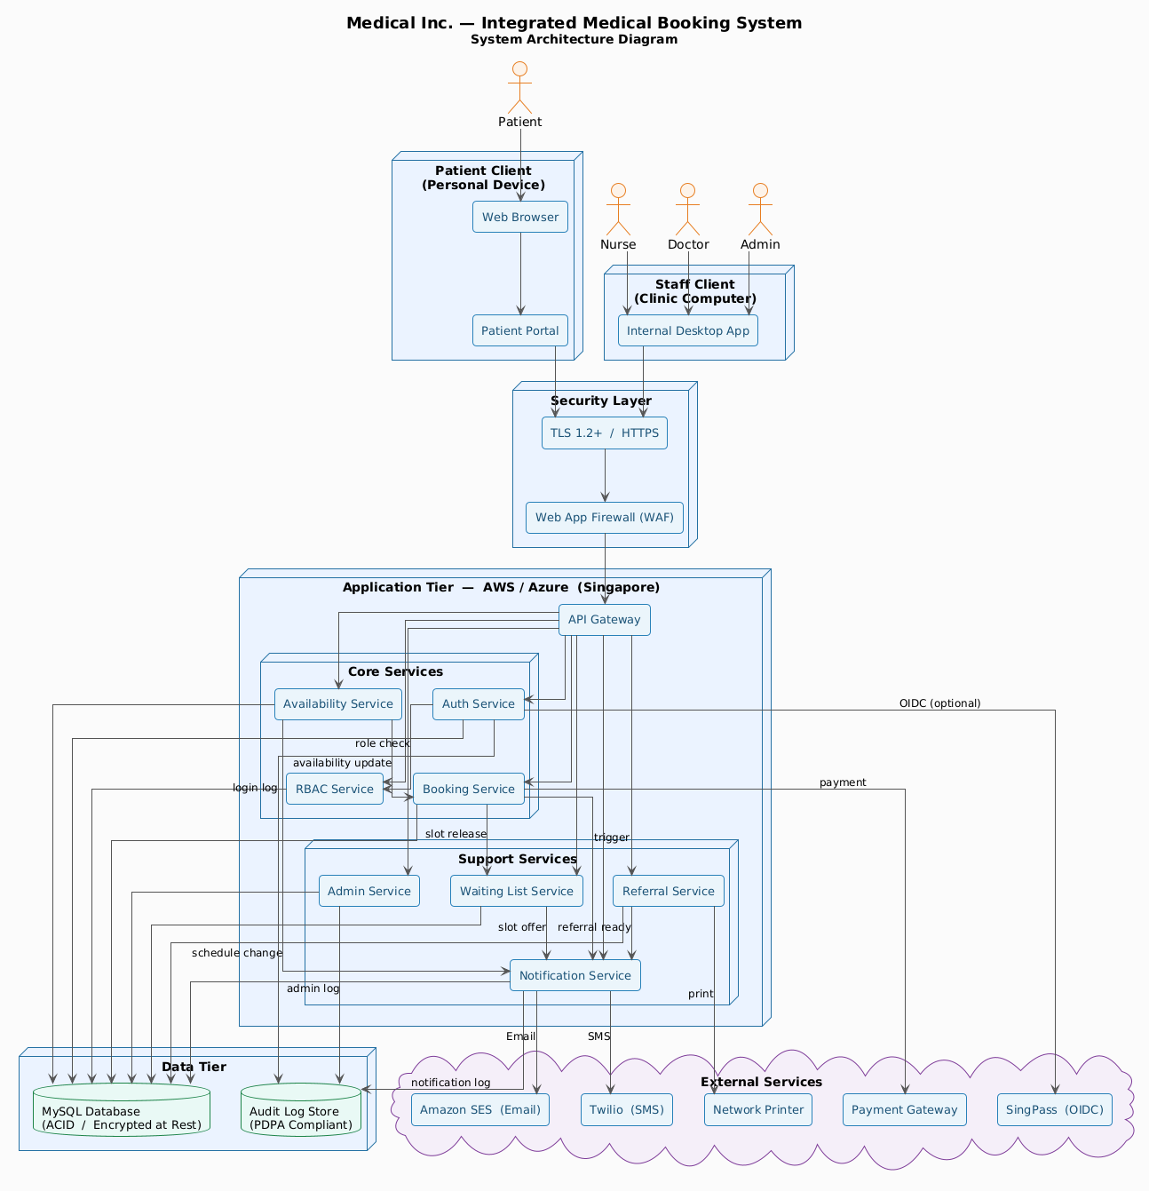

Database ER Diagram
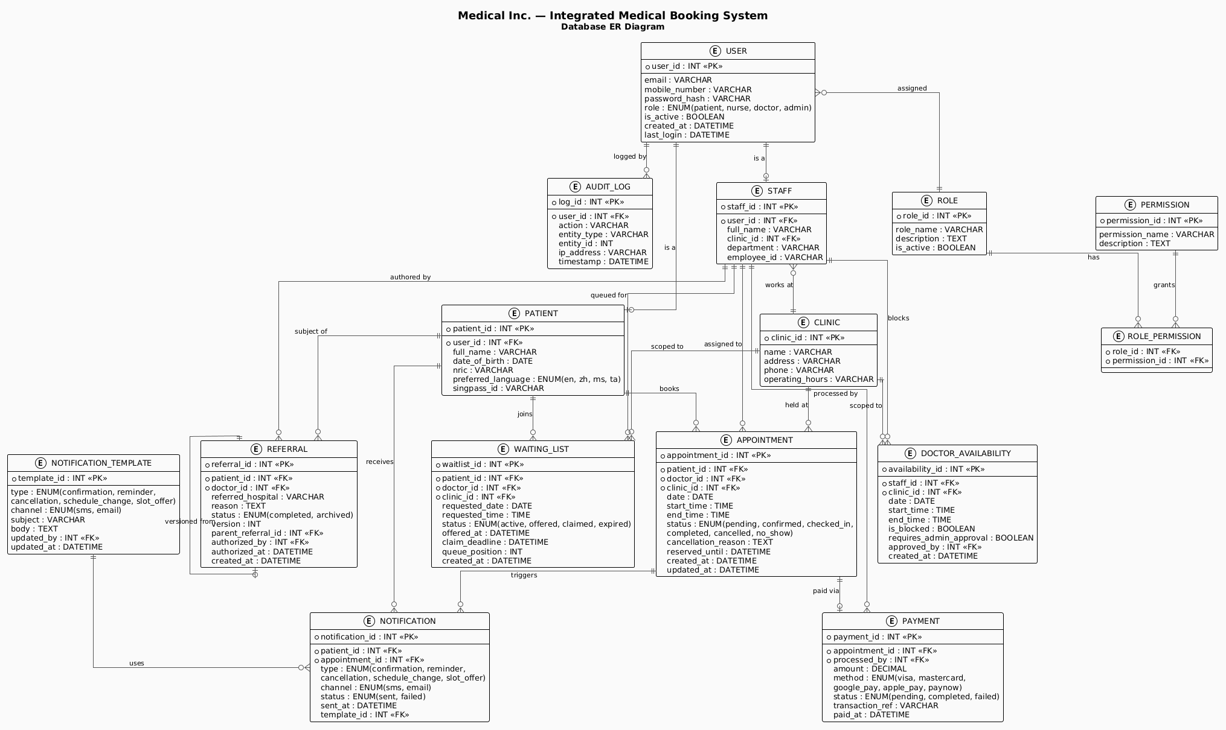
Appendix F

Repository
All project artifacts, including the Project Specification (PS), Analysis Report, Software Requirements Specification (SRS), iRTM, and UML diagrams, are maintained in the project repository:

GitHub Repository: https://github.com/Pingu-Tech/Medical-Inc-Integrated-Booking-System

This repository contains all supporting documents for the project, allowing traceability and verification of requirements.
Appendix G

Integrated Requirements Traceability Matrix (iRTM)

Requirement ID | Requirement Description | Source (PS / Stakeholder) | SRS Section | Related Model / Feature | Verification Method
External Interface Requirements
FR-UI-01 | The system shall be fully functional and visually consistent across the latest stable versions of Google Chrome, Mozilla Firefox, and Apple Safari. | Stakeholder (Usability) | 3.1. User Interfaces | User Interface | Demonstration / Test
FR-UI-02 | The interface shall employ a "Mobile First" responsive design, supporting screen widths ranging from 375px (mobile) to 1920px (desktop). | Stakeholder (Usability) | 3.1. User Interfaces | User Interface | Demonstration / Test
FR-UI-03 | All UI components shall adhere to WCAG 2.1 Level AA standards to support elderly users and those with visual impairments. | Stakeholder (Accessibility) | 3.1. User Interfaces | User Interface | Inspection / Test
FR-UI-04 | System navigation shall ensure that core features are reachable within a maximum of three (3) clicks from the main dashboard. | Stakeholder (Usability) | 3.1. User Interfaces | User Interface | Demonstration / Test
FR-HWI-01 | The application shall be deployed on secure, scalable cloud infrastructure (e.g., AWS or Azure) with data residency in Singapore. | Project Specification (CO-6) | 3.2. Hardware Interfaces | Infrastructure | Inspection
FR-HWI-02 | The system shall require a minimum of 4GB RAM and a modern processor for optimal performance on clinic-provided computers. | Stakeholder (IT Ops) | 3.2. Hardware Interfaces | Infrastructure | Inspection
FR-HWI-03 | The system shall interface with network printers for the generation of physical appointment slips and payment receipts. | Stakeholder (Clinic Ops) | 3.2. Hardware Interfaces | Appointment Booking | Demonstration / Test
FR-SI-SP-01 | The system shall integrate with the GovTech SingPass OIDC API to facilitate secure identity verification. | Project Specification (DE-3) | 3.3. Software Interfaces | User Registration & Auth. | Demonstration / Test
FR-SI-DB-01 | The system shall interface with a Relational Database (e.g., MySQL) for ACID-compliant storage of patient records. | Project Specification (CO-3) | 3.3. Software Interfaces | Data Layer | Inspection
FR-SI-NTF-01 | The system shall interface with the Twilio REST API for SMS alerts and the Amazon SES API for emails. | Project Specification (DE-2) | 3.3. Software Interfaces | Notification Management | Demonstration / Test
FR-SI-SEC-01 | The system shall integrate with a Web Application Firewall (WAF) to mitigate common OWASP Top 10 vulnerabilities. | Stakeholder (Security) | 3.3. Software Interfaces | Security | Inspection
FR-CPI-01 | All data transmitted between the client and server must be encrypted using TLS 1.2 or higher via HTTPS. | Project Specification (CO-5) | 3.4. Communication Protocols | Security | Inspection / Test
FR-CPI-02 | All external software interfaces shall utilize RESTful architectural style with JSON data payloads. | Project Specification (Internal) | 3.4. Communication Protocols | Integration Layer | Inspection
FR-CPI-03 | The system shall implement an exponential backoff retry mechanism for external API calls during service timeouts. | Stakeholder (Reliability) | 3.4. Communication Protocols | Integration Layer | Test
System Features
FR-AUTH-01 | Users shall be able to create a new account by providing a valid email address and mobile number. | Project Specification | 4.1. User Registration & Auth. | User Registration & Auth. | Demonstration / Test
FR-AUTH-02 | Users shall be able to view their profile information including email, mobile number, and account creation date. | Stakeholder (Patients) | 4.1. User Registration & Auth. | User Registration & Auth. | Demonstration / Test
FR-AUTH-03 | Users shall be able to update their profile information including mobile number and password. | Stakeholder (Patients) | 4.1. User Registration & Auth. | User Registration & Auth. | Demonstration / Test
FR-AUTH-04 | Users shall be able to request account deactivation. Administrators shall have the ability to permanently delete user accounts in compliance with data retention policies. | Stakeholder (Compliance) | 4.1. User Registration & Auth. | User Registration & Auth. | Demonstration / Test
FR-AUTH-05 | Passwords shall contain a minimum of 8 characters, at least one uppercase letter, one lowercase letter, one number and one special character. | Stakeholder (Security) | 4.1. User Registration & Auth. | User Registration & Auth. | Test
FR-AUTH-06 | The system may support optional registration and login via SingPass. | Project Specification (DE-3) | 4.1. User Registration & Auth. | User Registration & Auth. | Demonstration / Test
FR-AUTH-07 | All login attempts shall be logged. | Stakeholder (Security) | 4.1. User Registration & Auth. | User Registration & Auth. | Inspection / Test
FR-AUTH-08 | The system shall lock a user account after five consecutive failed login attempts and require password reset or administrator verification. | Stakeholder (Security) | 4.1 User Registration & Authentication | Account Security / Brute Force Protection | Test
FR-AUTH-09 | User sessions shall automatically expire after 15 minutes of inactivity and require re-authentication. | Stakeholder (Security / Compliance) | 4.1 User Registration & Authentication | Session Management | Test
FR-RBAC-01 | Administrators shall be able to create new roles with custom permission sets and assign roles to users. | Stakeholder (Admin) | 4.2. Role Based Access Control | Role Based Access Control | Demonstration / Test
FR-RBAC-02 | The system shall read the user's role upon login and display the appropriate dashboard and menu options. | Project Specification | 4.2. Role Based Access Control | Role Based Access Control | Demonstration / Test
FR-RBAC-03 | Administrators shall be able to modify role permissions and reassign users to different roles. | Stakeholder (Admin) | 4.2. Role Based Access Control | Role Based Access Control | Demonstration / Test
FR-RBAC-04 | Administrators shall be able to deactivate roles ensuring no active users are assigned to deleted roles. | Stakeholder (Admin) | 4.2. Role Based Access Control | Role Based Access Control | Test
FR-RBAC-05 | Patients shall see booking options, appointment history, and profile management. | Project Specification | 4.2. Role Based Access Control | Role Based Access Control | Demonstration / Test
FR-RBAC-06 | Nurses shall manage appointment schedules, patient check-in/payment, and basic medical/prescription data. | Project Specification | 4.2. Role Based Access Control | Role Based Access Control | Demonstration / Test
FR-RBAC-07 | Doctors shall see their appointment schedules, patient lists, and have access to in-depth medical records. | Project Specification | 4.2. Role Based Access Control | Role Based Access Control | Demonstration / Test
FR-RBAC-08 | Administrators shall access clinic management, reporting, and user oversight panels. | Project Specification | 4.2. Role Based Access Control | Role Based Access Control | Demonstration / Test
FR-BOOK-01 | Patients shall be able to create a new appointment booking by selecting an available doctor, date, and time slot. | Project Specification | 4.3. Appointment Booking & Mgmt | Appointment Booking & Mgmt | Demonstration / Test
FR-BOOK-02 | Patients shall view their upcoming and past appointments including details. Staff can view all appointments based on permissions. | Stakeholder (Patients/Staff) | 4.3. Appointment Booking & Mgmt | Appointment Booking & Mgmt | Demonstration / Test
FR-BOOK-03 | Patients shall be able to reschedule appointments >24h in advance. Staff can update appointment status. | Stakeholder (Patients/Staff) | 4.3. Appointment Booking & Mgmt | Appointment Booking & Mgmt | Demonstration / Test
FR-BOOK-04 | Patients shall be able to cancel appointments >24h in advance. Staff can cancel at any time. | Stakeholder (Patients/Staff) | 4.3. Appointment Booking & Mgmt | Appointment Booking & Mgmt | Demonstration / Test
FR-BOOK-05 | Patients shall view real-time availability of doctors, filtered by clinic and date. | Stakeholder (Patients) | 4.3. Appointment Booking & Mgmt | Appointment Booking & Mgmt | Demonstration / Test
FR-BOOK-06 | Patients shall be limited to one active appointment per clinic per day. | Stakeholder (Business Rule) | 4.3. Appointment Booking & Mgmt | Appointment Booking & Mgmt | Test
FR-BOOK-07 | When a patient selects an available time slot, it shall be temporarily reserved for 5 minutes. | Stakeholder (Concurrency) | 4.3. Appointment Booking & Mgmt | Appointment Booking & Mgmt | Test
FR-BOOK-08 | Patients can freely cancel or reschedule appointments more than 24 hours in advance. | Stakeholder (Patients) | 4.3. Appointment Booking & Mgmt | Appointment Booking & Mgmt | Demonstration / Test
FR-BOOK-09 | Patients shall not be able to cancel or reschedule appointments via the system within 24 hours of the appointment time. | Stakeholder (Business Rule) | 4.3. Appointment Booking & Mgmt | Appointment Booking & Mgmt | Test
FR-NTF-01 | The system shall automatically create and send notifications when triggered by specific events. | Stakeholder (Patients) | 4.4. Notification Management | Notification Management | Demonstration / Test
FR-NTF-02 | Administrators shall be able to view notification logs including recipient, type, status, and timestamp. | Stakeholder (Admin) | 4.4. Notification Management | Notification Management | Demonstration / Test
FR-NTF-03 | Administrators shall be able to update notification templates for different notification types. | Stakeholder (Admin) | 4.4. Notification Management | Notification Management | Demonstration / Test
FR-NTF-04 | Administrators shall be able to archive old notification logs according to data retention policies. | Stakeholder (Compliance) | 4.4. Notification Management | Notification Management | Inspection / Test
FR-NTF-05 | A confirmation notification shall be sent immediately after a booking is successfully completed. | Stakeholder (Patients) | 4.4. Notification Management | Notification Management | Demonstration / Test
FR-NTF-06 | A reminder notification shall be sent 24 hours before a scheduled appointment. | Stakeholder (Patients) | 4.4. Notification Management | Notification Management | Demonstration / Test
FR-NTF-07 | A cancellation notification shall be sent immediately to the patient and relevant clinic staff when an appointment is cancelled. | Stakeholder (Patients/Staff) | 4.4. Notification Management | Notification Management | Demonstration / Test
FR-NTF-08 | Patients whose appointments are impacted by a doctor's schedule change shall be notified immediately. | Stakeholder (Patients) | 4.4. Notification Management | Notification Management | Demonstration / Test
FR-DOC-01 | Doctors shall be able to create unavailability blocks. Administrators can create unavailability on behalf of doctors. | Stakeholder (Doctors/Admin) | 4.5. Doctor Availability Mgmt | Doctor Availability Mgmt | Demonstration / Test
FR-DOC-02 | Doctors shall view their current availability schedule. Patients shall read available time slots. | Stakeholder (Doctors/Patients) | 4.5. Doctor Availability Mgmt | Doctor Availability Mgmt | Demonstration / Test
FR-DOC-03 | Doctors shall be able to modify existing unavailability blocks at least 48 hours in advance. Within 48 hours, modifications require administrator approval. | Stakeholder (Doctors) | 4.5. Doctor Availability Mgmt | Doctor Availability Mgmt | Test
FR-DOC-04 | Doctors shall be able to remove unavailability blocks, provided no patients were affected. | Stakeholder (Doctors) | 4.5. Doctor Availability Mgmt | Doctor Availability Mgmt | Demonstration / Test
FR-DOC-05 | Doctors can block out personal time, provided the change is made at least 48 hours in advance. | Stakeholder (Doctors) | 4.5. Doctor Availability Mgmt | Doctor Availability Mgmt | Test
FR-DOC-06 | Any unplanned unavailability within 24 hours of an appointment must be approved by an administrator. | Stakeholder (Business Rule) | 4.5. Doctor Availability Mgmt | Doctor Availability Mgmt | Test
FR-DOC-07 | The system shall automatically identify affected patients and trigger the notification process. | Stakeholder (Patients) | 4.5. Doctor Availability Mgmt | Notification Management | Test
FR-WL-01 | Patients shall be able to join a waiting list for a specific doctor, date, and time slot. | Stakeholder (Patients) | 4.6. Waiting List Management | Waiting List Management | Demonstration / Test
FR-WL-02 | Patients shall be able to view their position in the waiting list. Staff shall be able to view the complete waiting list. | Stakeholder (Patients/Staff) | 4.6. Waiting List Management | Waiting List Management | Demonstration / Test
FR-WL-03 | The system shall automatically update waiting list positions when slots become available and when patients claim or decline offers. | Project Specification | 4.6. Waiting List Management | Waiting List Management | Test
FR-WL-04 | Patients shall be able to remove themselves from the waiting list at any time. | Stakeholder (Patients) | 4.6. Waiting List Management | Waiting List Management | Demonstration / Test
FR-WL-05 | Patients who attempt to book a fully booked slot may be given the option to join a waiting list on a first-come-first-serve basis. | Project Specification | 4.6. Waiting List Management | Waiting List Management | Demonstration / Test
FR-WL-06 | When a slot becomes available, the first patient on the waiting list shall be notified. | Stakeholder (Patients) | 4.6. Waiting List Management | Waiting List Management | Test
FR-WL-07 | The offered slot must be claimed within 2 hours. If not claimed, the system shall offer the slot to the next patient. | Stakeholder (Business Rule) | 4.6. Waiting List Management | Waiting List Management | Test
FR-REF-01 | Doctors shall be able to create a new referral letter by populating a template. The system shall create a referral record. | Stakeholder (Doctors) | 4.7. Referral Processing | Referral Processing | Demonstration / Test
FR-REF-02 | Authorized users shall be able to view referral letters based on their permissions. | Stakeholder (Staff/Patients) | 4.7. Referral Processing | Referral Processing | Demonstration / Test
FR-REF-03 | Doctors shall be able to update referral letters. Any update shall create a new version while preserving the original. | Stakeholder (Doctors) | 4.7. Referral Processing | Referral Processing | Test
FR-REF-04 | Completed referral letters cannot be permanently deleted. Administrators may archive a referral. | Stakeholder (Compliance) | 4.7. Referral Processing | Referral Processing | Test
FR-REF-05 | Nurses shall be able to provide referral letters given by doctors to patients, via print or secure electronic copy. | Stakeholder (Nurses) | 4.7. Referral Processing | Referral Processing | Demonstration / Test
FR-REF-06 | All referral letters shall be stored as part of the patient's permanent digital record. | Stakeholder (Compliance) | 4.7. Referral Processing | Referral Processing | Inspection
Other Non-Functional Requirements
NFR-PERF-01 | All web pages shall load within 5 seconds under normal network conditions. | Stakeholder (Performance) | 5.1. Performance Requirements | System Performance | Test
NFR-PERF-02 | A complete booking transaction shall complete within 10 seconds. | Stakeholder (Performance) | 5.1. Performance Requirements | System Performance | Test
NFR-PERF-03 | The system shall support a minimum of 100 concurrent active users without performance degradation. | Stakeholder (Performance) | 5.1. Performance Requirements | System Performance | Test
NFR-SAFE-01 | The system shall prevent partial or corrupted appointment records from being saved. | Stakeholder (Reliability) | 5.2. Safety Requirements | Data Integrity | Test
NFR-SAFE-02 | In the event of a booking transaction failure, the system shall clearly notify the user and ensure no duplicate appointments. | Stakeholder (Reliability) | 5.2. Safety Requirements | Appointment Booking | Test
NFR-SAFE-03 | The system shall require explicit user confirmation before completing irreversible actions. | Stakeholder (Usability) | 5.2. Safety Requirements | User Interface | Inspection / Test
NFR-SAFE-04 | In the event of temporary service unavailability, clinic staff shall retain read-only access to existing appointment schedules. | Stakeholder (Ops Continuity) | 5.2. Safety Requirements | System Resilience | Test
NFR-SEC-01 | The system shall be designed and maintained in full compliance with Singapore's PDPA and MOH guidelines. | Project Specification (CO-4) | 5.3. Security Requirements | Security & Compliance | Inspection
NFR-SEC-02 | All sensitive patient data shall be encrypted at rest and in transit (TLS 1.2+). | Project Specification (CO-5) | 5.3. Security Requirements | Security & Compliance | Inspection / Test
NFR-SEC-03 | Audit logs shall track all access to sensitive patient data. All administrative actions shall be logged. | Stakeholder (Security) | 5.3. Security Requirements | Security & Compliance | Inspection / Test
NFR-SEC-04 | The system shall support configurable data retention and deletion policies in accordance with PDPA. | Stakeholder (Compliance) | 5.3. Security Requirements | Security & Compliance | Demonstration / Test
NFR-SEC-05 | Patient consent mechanisms shall be integrated into all relevant data collection points. | Stakeholder (Compliance) | 5.3. Security Requirements | Security & Compliance | Inspection
NFR-SEC-06 | Regular security testing must be conducted pre-launch and at least annually thereafter. | Stakeholder (Security) | 5.3. Security Requirements | Security & Compliance | Inspection
NFR-AV-01 | The patient booking portal shall achieve at least 99% uptime, measured monthly. | Stakeholder (Reliability) | 5.4. Software Quality Attributes | System Performance | Inspection / Test
NFR-REL-01 | The system shall maintain 100% data consistency with zero data loss in the event of a component failure. | Stakeholder (Reliability) | 5.4. Software Quality Attributes | Data Integrity | Test
NFR-SCAL-01 | The system architecture shall support the onboarding of additional clinic locations without requiring core system redesign. | Stakeholder (Scalability) | 5.4. Software Quality Attributes | System Architecture | Inspection
NFR-MON-01 | The system shall include centralized logging, monitoring, and alerting mechanisms. | Stakeholder (Maintainability) | 5.4. Software Quality Attributes | System Maintenance | Inspection
NFR-MOD-01 | Compliance logic shall be modularized to accommodate regulatory changes with minimal impact. | Stakeholder (Maintainability) | 5.4. Software Quality Attributes | System Architecture | Inspection
Project & User Documentation
PD-REQ-01 | The vendor shall provide a Solution Architecture Diagram. | Stakeholder (Technical) | 5.6. Project Documentation | Documentation | Inspection
PD-REQ-02 | The vendor shall provide a High-Level Data Model. | Stakeholder (Technical) | 5.6. Project Documentation | Documentation | Inspection
PD-REQ-03 | The vendor shall provide monthly progress reports. | Stakeholder (Project Mgmt) | 5.6. Project Documentation | Project Management | Inspection
UD-REQ-01 | The vendor shall provide user manuals and quick-reference guides for all user roles. | Stakeholder (Training) | 5.7. User Documentation | Documentation | Inspection
UD-REQ-02 | The vendor shall provide training materials and conduct training sessions for clinic staff and administrators. | Stakeholder (Training) | 5.7. User Documentation | Documentation / Training | Demonstration

